**Chapter 3**

Judy, who is new to town, has decided to join the local chapter of a woman’s volunteer club that undertakes a number of charitable events and outreach programs. It has approximately 150 current members as well as 30 provisional members (a new member before she becomes a full member). The club would like to create a single table database that could be used to maintain a membership directory and print mailing labels. This table should include each member’s first name, last name, street address, city, state, zip code, phone, fax, e-mail address, the community in which she lives, whether she receives the newsletter via regular mail or e-mail, and whether she is a provisional member.

The club wants to be able to query this table to

1. Create a list of those members who receive the newsletter by mail.
2. Make an alphabetic list of all members' first name, last name and e-mail address for those members with email addresses.
3. Make a special directory for those members who live in the communities HG, AG, CLI, and CC (this should be in order by community and within community by last name).
4. Make a master directory that lists the current members in alphabetical order and followed by the provisional members in alphabetical order.

Create the single table and write the preceding queries.

**Chapter 4**

The club has asked you to extend the initial database to include some more detail.

The club has asked you to extend the initial database to include some more detail. There are seven committees, each of which undertakes between three and seven events per year. All club members must join one, and only one, committee. Each committee has a name and specific mission and works on several projects during the year. These projects are given names, take place in specific locations, and have a begin date and time as well as an end date and time. There is also a short description for each event, which is run by one, and only one, committee.

Create the data model and write the following queries.

1. How many events did each committee undertake in 2001?
2. List the names of all club members by committee membership. List the committee name, the last name and first name of each member in that committee as well as that person's phone number.
3. List the committees that have fewer than 10 people. Sort the report in descending order of the number of committee members.
4. Find all of the missions (these are the committee's missions) that had an event taking place in the current month.
5. Find all committees with an event that took place in “JRs Park”.

**Chapter 5**

You need to modify the earlier data model to include the following detail.

* An event may be organized by one or more committees.
* A club member can work on any event regardless of committee affiliation.
* Events receive donations that have a monetary value, a description, and the name of the club member who is the contact person for each donation. It is necessary to show if the donation has been received.
* Donations come from one and only one donor, but a donor can make many donations.
* Donor information includes the name of the donating organization, address, phone number, contact person, and the contact person’s home phone number, cell number, fax number, work phone number, and e-mail address.
* Each event benefits one or more charities and a charity may also benefit from one or more events.
* For each charity, we want to track its name, contact information, personal contact, and a description of its work.
* For each event, the benefiting charities receive a percentage of the proceeds (for instance, from the Fall Ball proceeds, MADD may get 50%, Habitat for Humanity 25%, and Sierra Club 25%).

After creating the data model, write the following queries:

1. List all events, their location, and the total value of the donations received for each event, in descending order of the total value received.
2. How many donors participated in each event?
3. Which events received no donations?
4. Which club members participated in more than three events?
5. List each event that has not taken place yet and the names and phone numbers of each member who is working on it.

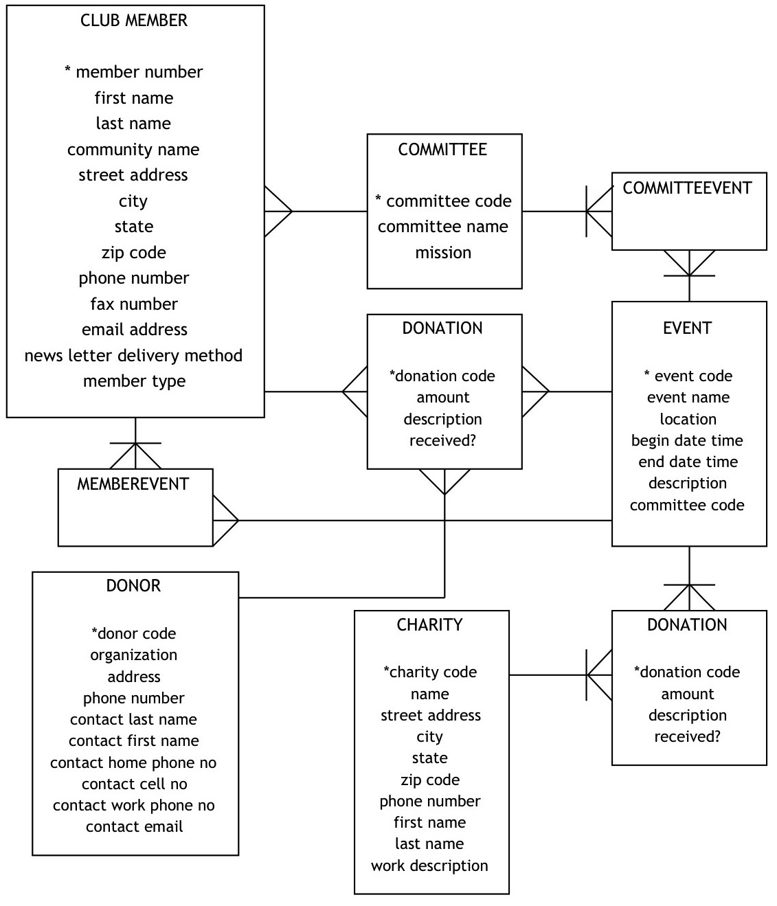

**Chapter 6**

Modify the earlier data model further to accommodate the following requirements. A club member first joins as a provisional member. All provisionals are given one or more mentors (a current club member) but a current club member can mentor at most one provisional member. All committees and events have chairpersons, and can have a treasurer and/or co-chairperson. A club member can be an officer of many committees.

Revise the data model and answer the following queries:

1. List all mentors and whom they are mentoring.
2. List all provisional members and their mentors.
3. List each event, the committee responsible for it, and the names of the chairpersons, co-chairs, and treasurers.
4. Which club members are mentoring more than two provisional members?
5. List all club members who have been an officer of at least three committees or events.